Potential CIL projects for July 2024 funding round.

Path on Whittington Playing Fields
Councillor Susan Smith
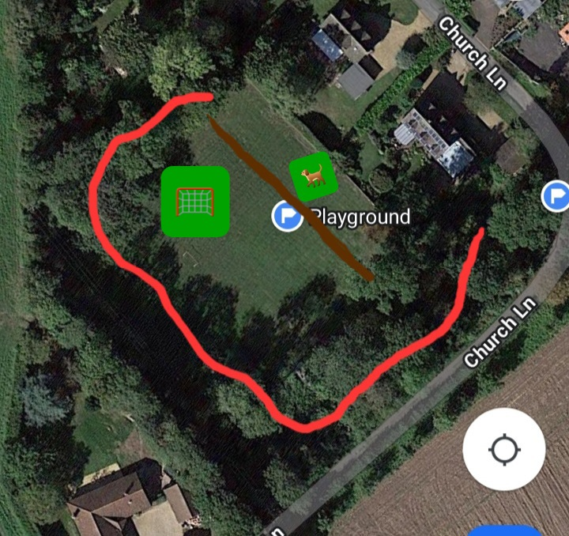
The brown line is the approximate fence line separating the dog area from our new playground equipment. The red line is an idea for placement of a path through the trees.
I would suggest wide enough and suitably surfaced to allow wheelchair/pushchair use.
The area surrounding the playground is wooded and inaccessible at the moment to all but the most adventurous of children and off lead dogs but a pathway would enable all to enjoy walking under the tree canopy, especially useful when trying to find some shade as the playground/dog area is in full sun most of the time.
It would be more enjoyable for dog walkers who may prefer to keep their dog on a lead than the open bare grass area.
Children could ride bikes around as well as being able to explore the area better.
If funding would allow, an information board could provide a guide to the different flora and fauna that can be looked for enroute and maybe an extra bench or two to allow folk to stop and rest amongst the trees.

